**Cover Page**

**COMPSCI 345 / SOFTENG 350 Human-Computer Interaction**

**Assignment One: Usability Evaluation**

**Student Name:** Sarah Ying Ying Zhang

**Student ID:** 397042883

**Student UPI:** szha677

____________________________________________________________________

Note: To ensure a fair playing field for all students in the class the University of Auckland will not tolerate cheating or assisting others to cheat, and views cheating in coursework as a serious academic offence.

Student Declaration:

* I declare that this work is my own work and reflects my own learning.
* I declare that where work from other sources (including sources on the world-wide web) has been used, it has been properly acknowledged and referenced.
* I understand that my assessed work may be reviewed against electronic source material using computerised detection mechanisms.

Place this page in the front as the first page of your document that you are submitting to Canvas

**Part One**

1. a. Label a stop – Rename the chosen stop.

b. Find stop – Looks for the stop you want by entering the stop number or stop address or finding the stop on the map.

c. Selecting route – After selecting a stop, show all the routes that goes through this stop and select the route(s).

d. Display stops – A list containing and displaying saved stops.

e. Edit route – When edit is tapped, choose another route(s) available from selecting route or deselecting chosen route.

f. Delete stop – Removes the selected stop to be deleted from the display stops.

g. Save stop – Saves the stop selection(s) made in selecting routes.

h. Stop map indicator – Tells how many stops away the bus is and displays current location and route of the bus.

i. Stop schedule –Display time of chosen route(s) that are scheduled to arrive in the next two hours at chosen stop and how many stops the closest bus is from chosen stop.

j. Schedule Backspace – Goes back from the stop schedule to the display stops.

k. Add stops – adds an additional stop to the display stops.

l. Stop number and address drop down list – Displays a drop down list of relating stop numbers or addresses typed in.

m. Drag stop(s) list – Rearrange order of saved stops on the display stops, option only available if there’s more than one stop saved.

n. Zoom in/out – Zoom in and out in any map displayed.

o. Left swipe – Swipe to the left to get edit route and delete stop.

p. Pull to refresh – Pull page you want to be refreshed down.

q. Tapped location button – Pulls up the location of the user on the map when the location icon is tapped.

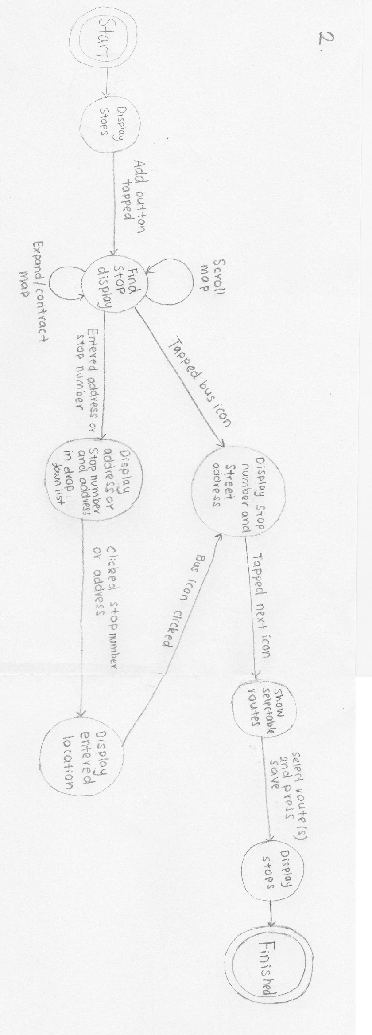

1. **Visibility of system status**:

This is applicable because the loading bar at the top is good for letting the users know they need to wait for information to be loaded rather than assuming the page is empty. Titles and labels on the upper part of page lets users know what part of the process they are on, such as finding a stop, selecting routes, etc. However, when finding a stop, once the bus icon is clicked, choosing to add that stop might be confusing as there is only an arrow indication to the right. Users may think that this gives further information about the stop rather than letting you select route(s) from the stop or to save the stop. The dragging stops function doesn’t tell the user what’s going on and they have to assume the action to get further information. Pull to refresh tells users what it will do but users may not know this function exists as it’s quite hidden. Another visibility issue is the location function does not react in a timely manner, apps needs to be closed down and reopened or refreshed for location function to work. Adding a new stop on the displaying stops page for the first time is difficult as users have to assume which button adds a new stop to the list (no clear label).But users can do guesswork on how to do add a new stop.

**Match between system and the real world:**

This is applicable because the app is only in English which matches where the system is used, only in New Zealand. The bus schedule is also in logical order with closest times at the top to the furthest times at the bottom. However, the arising issues is the icon for dragging stops to rearrange their order is confusing, I thought it was a drop down function that was not working and the button to change the swipe left to drag function looks like its supposed to change the volume of the app. Looks very similar to the Samsung Galaxy sound system adjustments. Pressing the back button on your phone exits the app when the list of saved stops is displayed, it exits the app instead of going back to the select routes (instead of going back to the previous phase).

**User control and freedom:**

This is applicable because the back button applies to when you have selected a stop but you no longer want that stop. Tapping on a bus icon on the find stop, the undo function is tapping anywhere else on the map. However there is not a back button for when you are looking at the stops list. Redo is not supported in this app. When you select routes for the chosen stop and user taps backspace, tapping on the same stop won’t recall the previous routes selected. When you edit a stop and select or deselect the route, then backspace, those changes won’t be saved.

**Consistency and standards:**

This is applicable because as it is inconsistent and consistent. There is inconsistency with the back button, when you press the back button on your phone while you’re on the page with the list of saved stops, it exits the app. When you press the back button on your phone anywhere else it goes back to the previous state you were in. On the stops list, when you change the swipe left function to the drag stop(s) list function, the label on top still says “swipe left for more information” even though swiping left does nothing in this state. Adding a new stop every time is consistent.

**Error prevention:**

This is applicable because when you begin typing in the stop number or address in the find stop page, a drop list appears with the recommendation that’s closest to what you have typed to aid you in finding your desired stop or area and you have to select the address or stop number from that list. Hence, prevents some spelling mistakes from occurring and non-existent areas from being searched. An issue with the drop down list is that in some cases spelling mistakes/garbled spelling, has no suggestions for the address user has typed e.g. (“Queesnt”, as a Queens Street typo has no street recommendation). There is also an error prevention in selecting route(s) from the selected stop as you are given a list to choose the route(s) from. It prevents route(s) from being chosen that do not go through that selected stop.

**Recognition rather than recall:**

This is applicable but instructions were brief, occurred when you first open the app, after that, it’s not retrievable. The system only requires the user to recall the area of stop number the stop is at or near and you also have to recall what route you’re supposed to be taking.

**Flexibility and efficient of use:**

N/A, accelerators not really applicable to apps but are applicable to machines to get around apps faster.

**Aesthetic and minimalist design:**

This is applicable because the app has an aesthetic and minimalist design. Colours used makes users instantly think of their company. No heavily cluttered pages and contains relevant dialogue to help users identify what they are doing and what they need to do next.

**Help users recognize, diagnose, and recover from errors:**

This is applicable because when Wi-Fi or data is not present an error message will occur, expressed in English, tells you the problem and tells you that some functions of the app won’t work. Also doesn’t tell users how they could potentially recover from them.

**Help and documentation:**

This is N/A because there is no help button on the app to help people need help using the user interface or navigating the site. No help or documentation on the website that concerns itself with the track my bus app. It only allows for feedback and suggestion improvements.[1]

**Part Two**

**Product under test**

The app is for displaying bus time arrivals, within the next two hours, to the chosen stop(s), which takes the selected route(s).

**Test objectives**

To test how fast it takes for users to familiarize themselves with the app. How long it takes for them to perform a task and find the mistakes they make. Discover if the app/function is fully functional.

**Participants required**

10 to 12 participants required as it’s the only New Zealand bus time arrival app, so cannot be compared. Wish to recruit elderly(65+), university students, high school students, English as a second language residents, mobile users who have used this app before and mobile users who have not. Users who are mobile proficient and those who are not.

**Tasks to undertake**

Test how long it takes them to add a new stop, to find a stop, to see the arrival time of the bus, to edit a stop, going back to previous pages and to delete a stop. Also test to see if they know how to refresh the page and drag the save stops. Not every part of the app can be tested due to limited time and resources so only the important task will be tested.

**Data collection**

Data for the time it takes for them to do a task, amount of mistakes made performing a specific task. Data will also be collected in forms of videos of participants doing the task and observation of participants. For this we need an observer and the participants. Participant feedback will also be collected.

**Test procedure**

Start the recording of the test.

“Hello _____, today we will be testing the track my bus app and you will now be a New Zealander living in Auckland, you use the buses daily to get to any destination and so to find out your bus times you use the track my buses app before you leave the house or go to any destination. Feel free to make comments as you use the app. Let’s begin”

Every time you ask the participants to do an action time how long it takes them to do that action and note down where the mistakes occurred and how many mistakes were made during that action. Record all the comments they make about the app.

“Now could you please open the track my bus app”. Wait for their response, help them if needed in opening the app, let them read the instruction pop up.

“Now find and chose the stop 7147 and select its route 220 and add it as your stop.” Wait for their response. Only help them if they state they don’t know how to proceed. Help them accordingly to accomplish the given task. Continue to do this throughout the procedure, every time they cannot accomplished the set task.

“Can you please view the bus time schedule of the stop 7417?”

“Can you please refresh this page?”

“Can you go back to your stop list?”

“Add a new stop, the closest stop to the locator, that’s on Queen Street, Auckland central with the route 258.”

“Change the order of the stops by putting the stop 7147 above the stop 7058”

“Add another route 211 to stop 7147.”

“Delete the stop 7058.”

“Remove the route 220 from the stop 7147”

“View where the bus is currently now for route 221, stop 7147.”

“Thank you for participating in the track my bus app. Your feedback will be used to help improve the product, thank you for coming.”

**Analysis**

The data found will be put into numerical form and a statistical report will be made from the data recorded. Data that cannot be put into numerical form, such as comments, will be group together with similar comments made by participants about the app and display that as a numerical form. Reword the comments to give the general idea of what the feedback was about. E.g. 4 out of 10 people said this …

**Results**

Results reported in a video of the participants using the app. Good way the creators can see where the issues are and what they need to fix. As well as writing a detailed report/document using averages of the time it takes the users to do a task, percentages of participants who successfully did the task and a percentage of where the most error occurred.

1. https://at.govt.nz/bus-train-ferry/more-services/mobile-services/